- A sample of 100 boxes of matches was taken and a record made of the number of matches per box. The results were as follows:

Number of matches, x | 47 | 48 | 49 | 50 | 51
Frequency, f | 4 | 20 | 35 | 24 | 17

Calculate the mean number of matches per box.

- On a certain day the number of books on 40 shelves in a library was noted and grouped as shown. Find the mean number of books on a shelf.

Number of books | 31 – 35 | 36 – 40 | 41 – 45 | 46 – 50 | 51 – 55 | 56 – 60
Number of shelves, f | 4 | 6 | 10 | 13 | 5 | 2

- The table shows the masses of a group of male students at a college. Find the mean

Mass (kg) | 60 – 64 | 65 – 69 | 70 – 74 | 75 – 79 | 80 – 84 | 85 – 89
Frequency | 4 | 27 | 42 | 60 | 35 | 12

- Find the median of each of the following sets of numbers:
(a) 4, 6, 18, 25, 9, 16, 22, 5, 20, 4, 8
(b) 192, 217, 189, 210, 214, 204

- Find the median of each of the following frequency distributions:
(a)
x | 5 | 6 | 7 | 8 | 9 | 10
f | 6 | 11 | 15 | 18 | 6 | 5

(b)
x | 12 | 13 | 14 | 15 | 16 | 17
f | 3 | 9 | 11 | 15 | 7 | 5

- The distribution of marks obtained by 199 students in a mathematics examination is shown in the table below:

Marks | 20 – 29 | 30 – 39 | 40 – 49 | 50 – 59 | 60 – 69 | 70 – 79 | 80 – 89
Frequency | 14 | 18 | 29 | 45 | 54 | 22 | 17

Construct a cumulative frequency table and use it to estimate the median mark.

- The length of life (to the nearest hour) of each of 50 electric light bulbs is noted and the results shown in the table below. Calculate the median length of life.

Length of life (h) | 660 – 669 | 670 – 679 | 680 – 689 | 690 – 699 | 700 – 709
Frequency | 3 | 7 | 20 | 17 | 3

- The marks of 5 students in a mathematics test were 27, 31, 35, 47, and 50. Calculate the mean mark and the standard deviation.

- The score for a round of golf for each 50 club members was noted. Find the mean score for a round and the standard deviation.

Score, x | 66 | 67 | 68 | 69 | 70 | 71 | 72 | 73
Frequency, f | 2 | 5 | 10 | 12 | 9 | 6 | 4 | 2

- The scores in an IQ test for 60 candidates are shown in the table. Find the mean score and the standard deviation.

Score | 100 – 106 | 107 – 113 | 114 – 120 | 121 – 127 | 128 – 134
Frequency | 8 | 13 | 24 | 11 | 4

Age 12 13 14 15 16 17 18 19 20 21 22 23 24 25 26 27 28 29
f 1 1 5 8 17 19 15 9 8 6 4 3 3 2 2 2 1 1

The table above gives the ages in completed years of the 107 persons convicted of shop-lifting in a town in 2010. Working in years and giving answers correct to 1 place of decimals, calculate
(a) the mean age and the standard deviation.
(b) the coefficient of skewness given by (mean - mode ) / standard deviation
(c) the median and modal age.
(d) which do you consider to be best as a representative average of the distribution - the mean, median or mode / Give reasons for your choice.

- In a borehole the thickness, in mm, of the 25 strata are shown in the table below:

Thickness (mm) | 10-20 | 20-30 | 30-40 | 40-50 | 50-60
Number of strata | 2 | 5 | 9 | 8 | 1

(a) Draw a histogram and determine the modal value.
(b) Construct a cumulative frequency table and draw a cumulative frequency polygon. Hence, or otherwise, estimate the median and the inter-quartile range of these data.
(c) Find the proportion of the strata that are less than 28 mm thick.

Answer:

1. 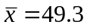
2. 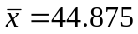
3. 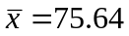
4. (a) Median = 9
(b) 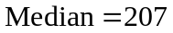
5. (a) 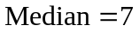
(b) 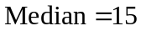
6. 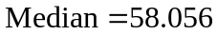
7. 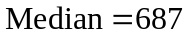
8. 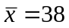 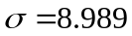
9. 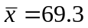 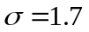
10. 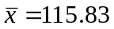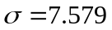
11. (a) 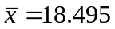 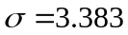
(b) The coefficient of skewness 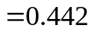
(c) Median 